**PL/SQL PROGRAMMING**

**Exercise 1: Control Structures**

**Scenario 1:** The bank wants to apply a discount to loan interest rates for customers above 60 years old.

* **Question:** Write a PL/SQL block that loops through all customers, checks their age, and if they are above 60, apply a 1% discount to their current loan interest rates.

**CODE:**

BEGIN

  FOR rec IN (

    SELECT l.LoanID

    FROM Loans l

    JOIN Customers c ON l.CustomerID = c.CustomerID

    WHERE MONTHS_BETWEEN(SYSDATE, c.DOB)/12 > 60

  ) LOOP

    UPDATE Loans

    SET InterestRate = InterestRate - 1

    WHERE LoanID = rec.LoanID;

  END LOOP;

  COMMIT;

END;

**OUTPUT:**

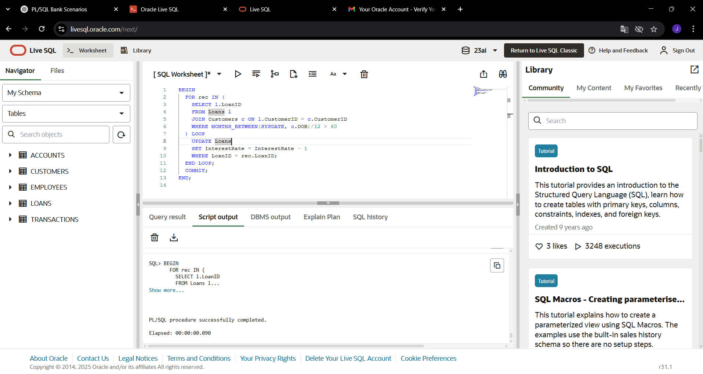

**Scenario 2:** A customer can be promoted to VIP status based on their balance.

* **Question:** Write a PL/SQL block that iterates through all customers and sets a flag IsVIP to TRUE for those with a balance over $10,000.

**CODE:**

BEGIN

FOR rec IN (

SELECT CustomerID FROM Customers WHERE Balance > 10000

) LOOP

UPDATE Customers

SET IsVIP = 'TRUE'

WHERE CustomerID = rec.CustomerID;

END LOOP;

COMMIT;

END;

**OUTPUT:**

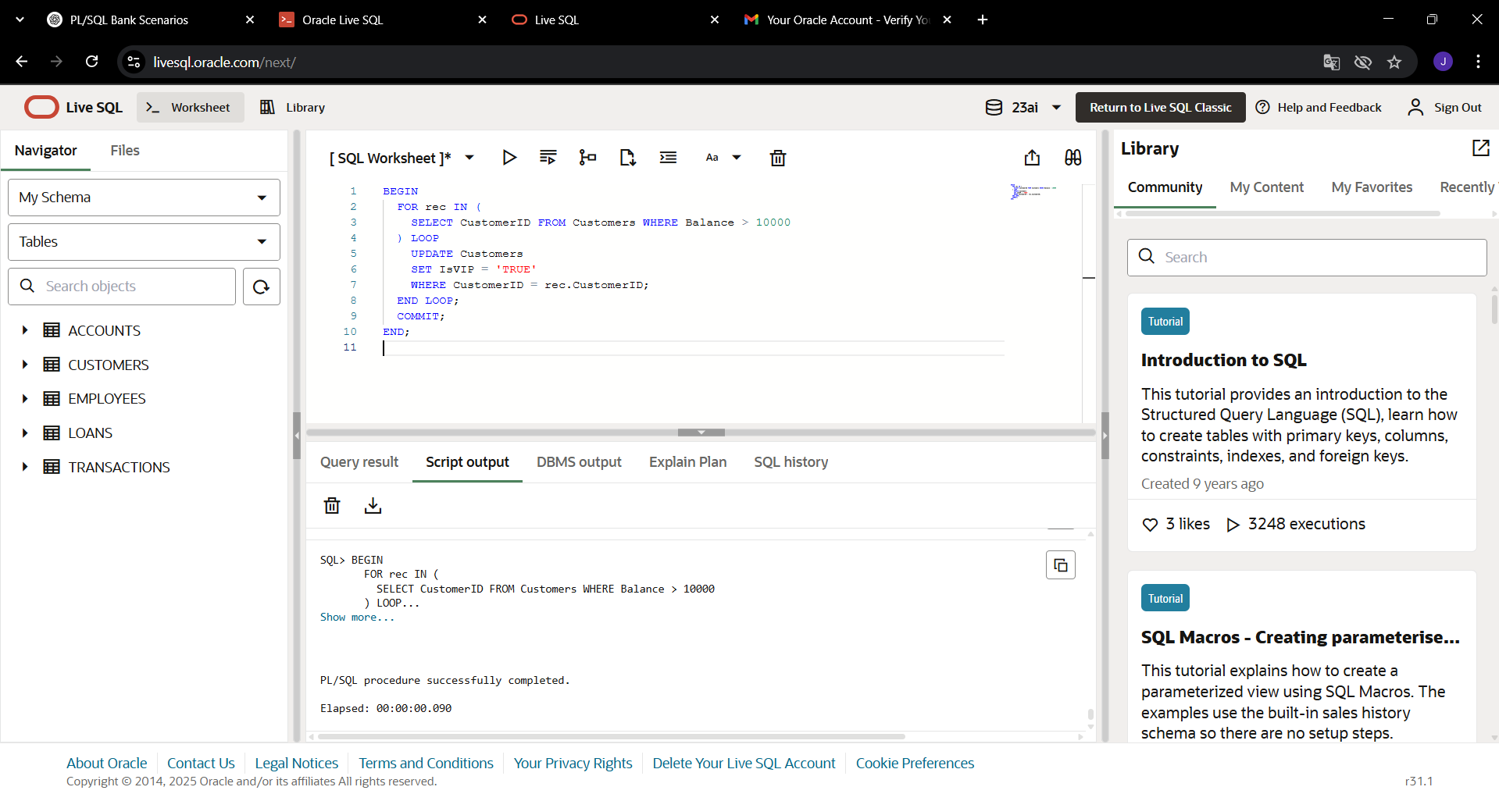

**Scenario 3:** The bank wants to send reminders to customers whose loans are due within the next 30 days.

* **Question:** Write a PL/SQL block that fetches all loans due in the next 30 days and prints a reminder message for each customer.

**CODE:**

BEGIN

FOR rec IN (

SELECT c.Name, l.EndDate

FROM Loans l

JOIN Customers c ON l.CustomerID = c.CustomerID

WHERE l.EndDate BETWEEN SYSDATE AND SYSDATE + 30

) LOOP

DBMS_OUTPUT.PUT_LINE('Reminder: Loan for ' || rec.Name || ' is due on ' || TO_CHAR(rec.EndDate, 'DD-MON-YYYY'));

END LOOP;

END;

**OUTPUT:**

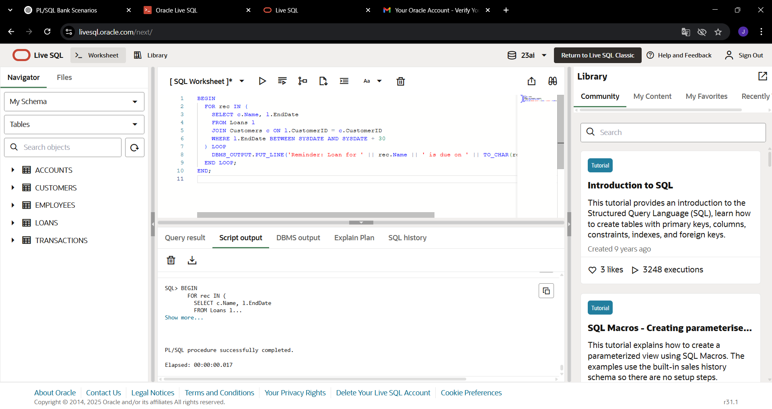

**Exercise 3: Stored Procedures**

**Scenario 1:** The bank needs to process monthly interest for all savings accounts.

* **Question:** Write a stored procedure **ProcessMonthlyInterest** that calculates and updates the balance of all savings accounts by applying an interest rate of 1% to the current balance.

**CODE:**

CREATE OR REPLACE PROCEDURE ProcessMonthlyInterest IS

BEGIN

FOR rec IN (

SELECT AccountID, Balance

FROM Accounts

WHERE AccountType = 'Savings'

) LOOP

UPDATE Accounts

SET Balance = Balance + (rec.Balance * 0.01),

LastModified = SYSDATE

WHERE AccountID = rec.AccountID;

END LOOP;

COMMIT;

END;

**OUTPUT:**

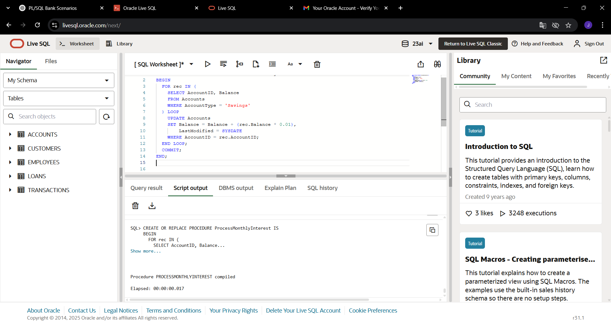

**Scenario 2:** The bank wants to implement a bonus scheme for employees based on their performance.

* **Question:** Write a stored procedure **UpdateEmployeeBonus** that updates the salary of employees in a given department by adding a bonus percentage passed as a parameter.

**CODE:**

CREATE OR REPLACE PROCEDURE UpdateEmployeeBonus(

p_Department IN VARCHAR2,

p_BonusPercent IN NUMBER

) IS

BEGIN

UPDATE Employees

SET Salary = Salary + (Salary * (p_BonusPercent / 100))

WHERE Department = p_Department;

COMMIT;

END;

/

EXEC UpdateEmployeeBonus('IT', 10);

**OUTPUT:**

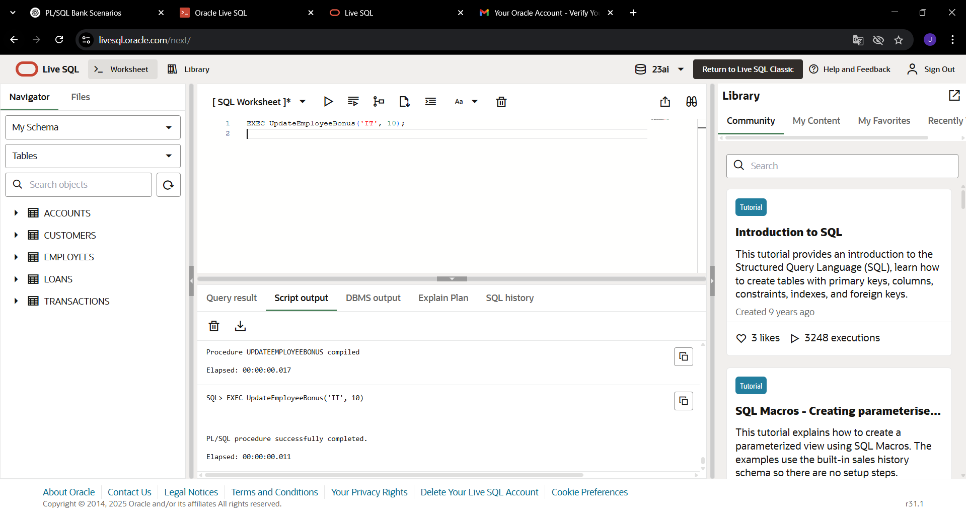

**Scenario 3:** Customers should be able to transfer funds between their accounts.

* **Question:** Write a stored procedure **TransferFunds** that transfers a specified amount from one account to another, checking that the source account has sufficient balance before making the transfer.

**CODE:**

CREATE OR REPLACE PROCEDURE TransferFunds(

p_FromAccountID IN NUMBER,

p_ToAccountID IN NUMBER,

p_Amount IN NUMBER

) IS

v_Balance NUMBER;

BEGIN

SELECT Balance INTO v_Balance

FROM Accounts

WHERE AccountID = p_FromAccountID

FOR UPDATE;

IF v_Balance < p_Amount THEN

RAISE_APPLICATION_ERROR(-20001, 'Insufficient funds in source account.');

END IF;

UPDATE Accounts

SET Balance = Balance - p_Amount,

LastModified = SYSDATE

WHERE AccountID = p_FromAccountID;

UPDATE Accounts

SET Balance = Balance + p_Amount,

LastModified = SYSDATE

WHERE AccountID = p_ToAccountID;

COMMIT;

END;

EXEC TransferFunds(1, 2, 500);

**OUTPUT:**

